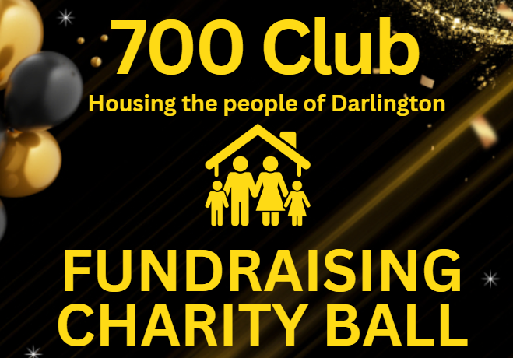
Event: | 700 Club Fundraising Charity Ball
Event date: | 3rd July 2026
Venue: | Mercure Hotel, Darlington
Time: | 6.30pm-7pm arrival / Carriages midnight
Dress Code: | Black tie
Lead Ticket Holder Details

Full name:

Organisation (if applicable):

Email:

Phone:

Address:

Guest Details
Please list guest names (or write "TBC")

Guests Full Name |  | Dietary Requirements
1.
2.
3.
4.
5.
6.
7.
8.
Please let us know if you have any accessibility requirements we can assist with.

Number of Individual tickets required
(£40 each)

Number of full tables
(8 guests - £300 per table)

Total Amount Payable: | £
Payment Method | Cash / Bank Transfer / Invoice
Bank Details: Lloyds: 700 Club / Account no: 88101260 / Sort Code: 30-92-79
Reference: 700 Club Ball

Terms & Conditions

- Tickets are non-refundable unless the event is cancelled. You may transfer to another named guest by notifying the organiser.
- Seating requests will be considered but cannot be guaranteed.

We will use your data solely to manage this booking and, if you opt in, to send charity updates, future events and ways to support the charity:

☐ I consent to being contacted about future events.

Signature of Lead Ticket Holder:

Date:

Please return this form to: emma.mclaughlin@700club.org.uk / Roadway House, Beaumont Street West, Darlington, DL1 5SX.

If you have any questions, you can contact Emma McLaughlin directly
on 01325 366397.

Thank you.

