**ACCESS Team** Referral Process

If the individual is already known to the local substance misuse service ACCESS will contact them to ensure they are still in treatment and adhering to their current treatment programme and assess whether further intervention/support methods can be put in place to assist treatment going forward

ACCESS will contact referred client to carry out initial assessment and ascertain the individuals needs around substance using. Information will be gathered from external services and the initial meeting to decide on the appropriate level of risk posed to staff and client

Client is referred from external organisation using phone, email, or designated ACCESS referral form

Referral is closed by ACCESS and relevant information is passed on to current treatment misuse service

If the client discloses there may be issues with them attending their appointments allocated ACCESS outreach workers can discuss a plan around possible obstacles effecting punctuality of appointments. Regular contact will be maintained with hard to engage clients leading up to appointments with the look to pass full independence to client

After providing initial assessment ACCESS will contact relevant treatment service (We Are With You) and client information will be passed on with consent to obtain the earliest available appointment. The information (Time, date, location) for the first appointment is passed on to client via text or paper format and arrangements will be discussed around possible issues of the client attending

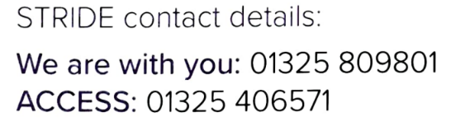

ACCESS team will liaise with treatment misuse service (We Are With You) leading up to initial assessment and follow up client where applicable to following appointments. Once treatment has been issued ACCESS will allow the individual to work alongside the treatment misuse service and monitor progress and if any lapses in treatment continuity occur ACCESS can re-intervene if necessary. Once the client shows a full level of independency with their treatment programme ACCESS will remove the client from their referral data

Potential opportunity to signpost client to third party services if outside factors are impacting on their substance misuse treatment e.g., housing, mental health, physical health, social issues