 |  | Tell your Mum |  | 
Tell your Nan | Is a pensioner you know entitled to Pension Credit and Winter Fuel payment?  Pensioners need to get Pension Credit to get extra help with fuel costs this year  Pensioners may get help even if they have savings or household income up to £633 per week*  Getting Pension Credit can also help with health costs such as dental treatment, glasses and hospital travel costs  Citizens Advice can help you check your entitlement and make the claim. To contact us either  call: 01325 734999 (Mon-Fri 2- 4 pm) or visit our offices in Church Row Darlington (Mon-Fri 10-12pm)  *Income Limit is based on incomes for a couple both of whom have disabilities and retired before 06/04/2016. For more details of income limits see overleaf. |  |  |  | Tell your Grandad
 |  | Tell your Dad | # 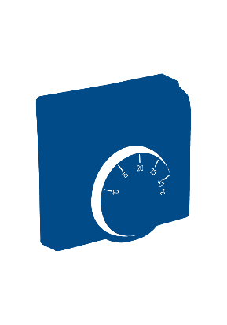

Pensioners may be entitled to Pension Credit if total weekly household income including pensions (but excluding Attendance Allowance) is under:
Health problems/Disability* | Weekly Income Limit ¹
 | Single | Couples
None | £218  £261# | £333  £281#
One pensioner with Disability/Health problems* | £299  £342# | £379  £425#
Both pensioners with Disability/Health problems* | - | £587  £634 #
Figures rounded to nearest £1
*May also require further claims we can help with
# Pensioners who retired before 06 April 2016 (must apply to both members of a couple)
¹ If income is higher pensioners may still get help with rent (housing benefit) and Council Tax (council tax support)

Other ways you can get help to claim:
- Telephone Age UK: 01325 357345 (Monday to Friday)
or call into their office at Bradbury House, West Beaumont Street, Darlington

- You can ring and fill in the form on the government’s National help line:
0800 99 1234

To receive the Winter Fuel Allowance, we advise you to claim Pension Credit before 21/12/24
You should request that your claim be claim be backdated 3 months in order to qualify for the winter fuel payment

In conjunction with BEAT (Supported by Darlington Borough Council)

