Mentoring for Independence  Tuesday night 5pm-7pm Term time only | 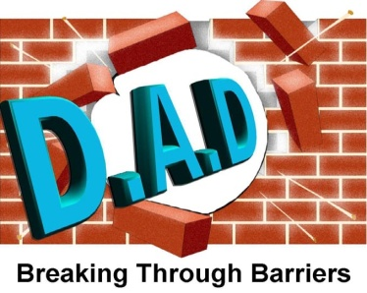
Darlington Association on Disability’s (DAD) Mentoring for independence project supports young people aged between 13-25 years old, to learn independent skills, through transition of being a child, to becoming a young adult.
Young people will gain confidence, self- esteem, build friendships, practical and emotional support, in a safe, flexible, friendly and fun environment.
This will be achieved through sessions key focuses on building skills such as:
- Travel training
- Cooking
- Budgeting
- Personal care
- Social awareness
Contact details:

Children and Young People’s service

01325489999 Ext 3

www.darlingtondisability.org

chyps@darlingtondisability.org
Charity number 1125848

