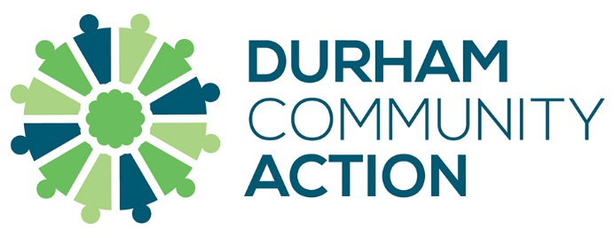

Micro-Commissioning of Youth Activities

Durham Community Action is jointly working with the Ballinger Charitable Trust and the National Lottery Community Fund to commission youth activities to be run by small volunteer-led groups.

Guidelines
- Commissions will be £1,000, with a maximum of one per group
- Monies must be spent on direct delivery in support of children and/or young people
- Commissions will not be awarded to individuals
- Commissioned sums must be spent within 12 months
- Any overall project costs to which a commission is awarded must be no more than £2,000 in total, and the commission monies will only be released when the project costs have been funded in total – this is included in the 12-month expenditure period above.
- Commissioned sums must be paid to a recognised community group bank account

Where a commission to a group is not secured, advice and guidance for further development from Durham Community Action will be provided to move the project forward.

Examples
These are examples only and any other youth-based activity will be considered:

- Purchase of equipment or resources for young people
- A day trip to a local/regional activity
- A sessional worker to deliver activities
- Sports activities which encourage participation

Exclusions

- Youth organisations based outside County Durham
- Uniformed Groups
- Schools
- Older people’s organisations (inter-generational work)
- Local Authorities
- Town Councils
- Hospices

Expression of Interest

Please complete the short Expression of Interest form below.

Shortlisted applicants will be invited to speak to the awarding panel about your project, in an online meeting at a date to be confirmed.

Name of your Group

Please tell us about your project. (What, where and when)

Please tell us about the main costs for your project.

Please return completed forms to Craig Hampton craig.hampton@durhamcommunityaction.org.uk by Friday 12th May – applications will be considered in June.

For any enquiries, please contact Craig on 07960 214537

