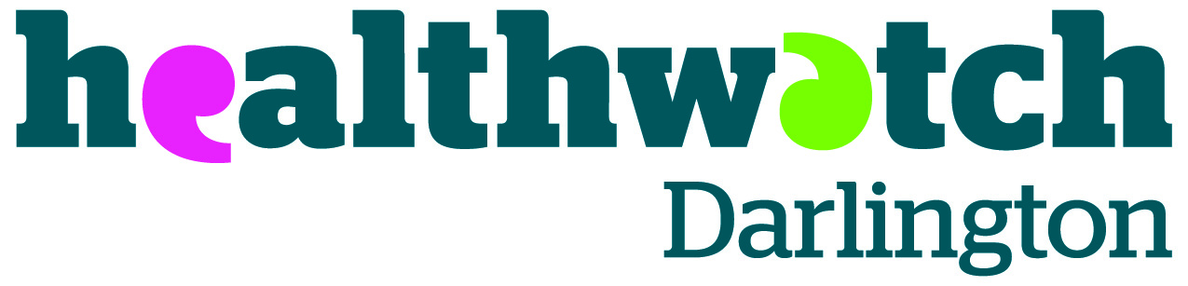

Darlington Organisations Together (DOT)
Thursday 17th March 2022 10:00am - 12.00noon
Zoom Meeting
https://us02web.zoom.us/j/83592413131

Agenda

- Welcome and Introductions
- Apologies
- Notes from the last meeting

- North East and North Cumbria VCSE Partnership Programme:

Lisa Taylor - VONNE Health and Wellbeing Programme Director
Siobhan Flynn - North East and North Cumbria VCSE Engagement Manager

- Around the room updates
- Healthwatch update
6. Any Other Business

Next DOT Meeting – Thursday 16th June 2022 10am-12pm

