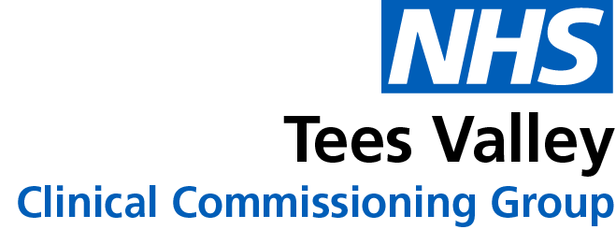
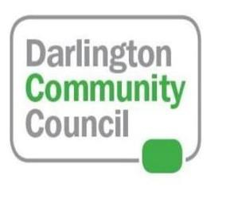
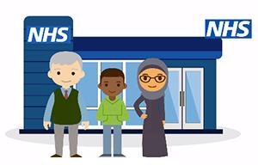

Could you be the next member of the Darlington Community Council?

- Do you want to improve health services in your town and local community?
- Do you want to have a voice and get involved in the way your health service is run?
- Do you want to get involved in shaping and delivering new and exciting services?

If you answered YES, you may be the next member of the Darlington Community Council!
We’re looking for people from all ages and backgrounds who want to make a difference and improve healthcare in their town.
If you'd like to find out more, please call 01325 380145, email info@healthwatchdarlington.co.uk or visit the NHS Tees Valley Clinical Commissioning Group

