

Darlington Mental Health Network News
Your Quarterly Update from the Mental Health Network
Issue: May 2025

The Mental Health Network met on 19 May 2025 at the Tandem Hub in Darlington. Here's a summary of key updates, announcements, and opportunities discussed at the meeting.

🌟 Network Funding Secured
Healthwatch Darlington have been awarded funding to facilitate the local Mental Health Network for another two years. This ensures continued support, collaboration, and development of mental health services in Darlington.


👤 Project Spotlight: Never Throw In The Towel

Anthony Hutton, founder of the Never Throw In The Towel project, presented an inspiring session focused on supporting men facing mental health challenges. His project, which has gained traction in the community, emphasises the power of conversation and peer-led support in preventing isolation and promoting wellbeing. 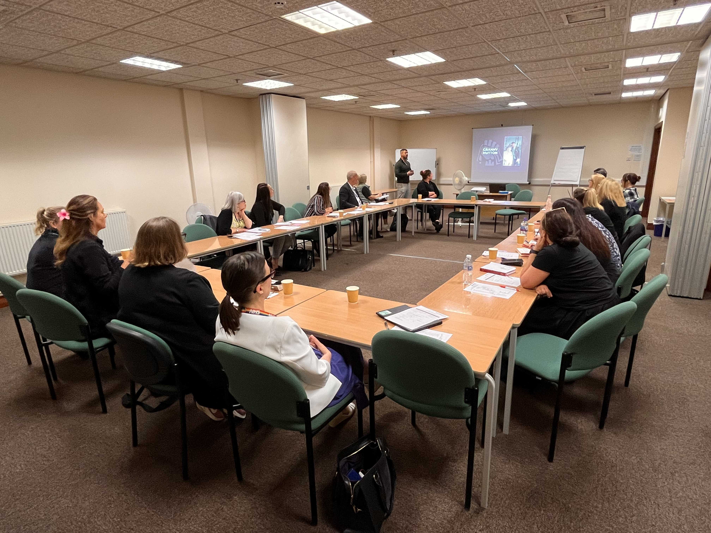

Pharmacy Services Update
Jane Harvey shared key updates from the Tees Valley pharmacy network. A new follow-up service is being rolled out for patients starting medication for 16 long-term conditions, which will include antidepressants from October. Patients will receive a check-in call to ensure support is in place during early or new treatment.

🏢 Organisation News and Announcements
Triage: Providing training, confidence-building, CV writing, and interview support to help people return to work. The initiative has proven life-changing for many participants.
TEWV: The crisis phoneline will close at 10am on 3 June 2025. NHS 111 option 2, should be used from that point onward.
Red Balloons: Funding is available for organisations offering peer support training.
Darlington Connect: Organisations can leave leaflets and book the rooms for free after 4:30pm on weekdays and any time on weekends.
Darlington Credit Union: Banks are now charging fees for setting up business accounts. Organisations are encouraged to explore cost-saving options.
0–19 HDFT: Drop-in sessions are now running in all secondary schools. The team is working to align services with the i-THRIVE framework for mental health.
Rethink: Providing money advice and GP referrals for people with mental health needs, including those leaving prison.
TEWV NHS Research: Exploring the connection between type 2 diabetes and depression in people with long-term conditions. Contact: emmanuel.chan@nhs.net
First Stop: Funding is an ongoing issue for the charity and concerns were raised for the lack of support/financial input into poverty in Darlington. Peer support funding remains currently, but only until the end of September for those supporting people in poverty.

🎪 Positive Wellbeing Events
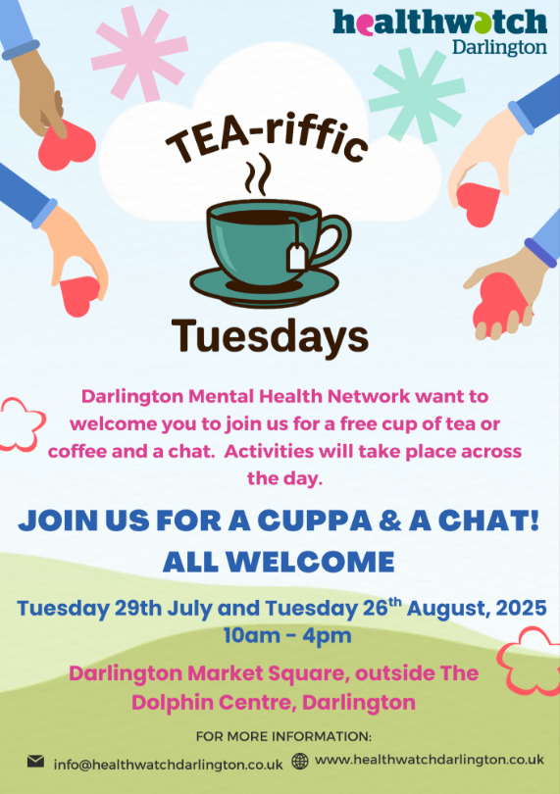
Two full-day Positive Wellbeing events are planned in Darlington Market Square:
- Tuesday 29 July - 10am – 4pm
- Tuesday 26 August - 10am – 4pm

Organisations are invited to attend and contribute items from a wish list which will be shared with the network in the upcoming weeks. Attendance for the full day is not a necessity.

Next Meeting
To add agenda items for the next meeting, please email: info@healthwatchdarlington.co.uk

