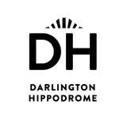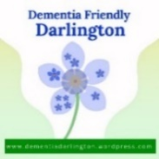**APPLY NOW**

**or NOMINATE SOMEONE YOU KNOW!**

 **Dementia Friendly Darlington presents…..**

**“DEMENTIA’S GOT TALENT”**

**TUESDAY 21ST JANUARY 2025 at DARLINGTON HIPPODROME**

**This is an exciting opportunity to be part of a trailblazing, fundraising talent show at the Hippodrome and become a star for a night. A big, glitzy, glamourous show featuring the talents of people living with dementia, their stories and about how much they can achieve.**

**Are you living with dementia and have a talent you would like share with an audience, from juggling, singing and dancing, comedy, playing the spoons, reading poetry, whistling and everything in-between welcome!**

**You can perform on your own on stage or have someone there to support you, or we can provide backing support of any kind.**

**To apply please fill in the form and return to: Dementia’s Got Talent, c/o Home Instead Darlington, Lingfield House, Lingfield Point, Darlington, DL1 1RW, or email:** [**joanne.hendry@darlington.homeinstead.co.uk**](mailto:joanne.hendry@darlington.homeinstead.co.uk) **or call: 07513 723302 and speak to Joanne for further information no later than 21st October 2024.**

**Relaxed auditions will be held during November, with rehearsals taking place during December and January. Can’t wait to see you!**

|  |  |
| --- | --- |
| **CONTACT INFORMATION**  **Name/s**    **Contact number/s** | **WHAT IS YOUR ACT/TALENT?**    **Any special requirements?**  **T & C’S Apply** |

***Sponsored by***

**In aid of Alzheimer’s Society**

**and dementia groups across Darlington**