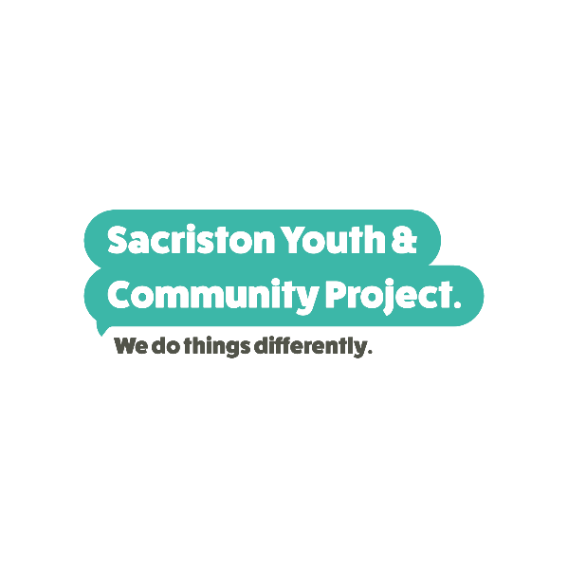
Emergency Contacts Over Christmas
Company | Contact info | Business Hours
Council Services – emergency social care & child welfare concerns including foster care | 03000267979 | Out of hours support
Council Services – Care Connect (community alarm service) | 03000262195 | Out of hours support
Council Services – Homeless or facing homelessness | 01388722538 | Out of hours support
Council Services – births, deaths and marriages services | 03000266000 | Out of hours support
County Durham & Darlington Fire and Rescue Service – advice about household fire safety | 0845 305 8383 | 24 hours
Crises Team (TEWV, Mental Health) | 0800 0516 171 | 24 hours
Debt Advice National Debt Line | 0808 808 4000
Durham Food bank – food and fuel bank, £49 credit x | Food and fuel vouchers 0300 330 9027 or 03000 260 260 | 9am-5pm
Freedom Programme Helpline | 01942 262 870 | 24 hours
Harbour Domestic Violence | 0300 020 2525 | 24 hours
HopelineUK (Support for under 35s at risk of suicide) | 08000684141  Text 07860039967 | 9am - Midnight
Household Emergency – Electricity if your power supply is interrupted | 0800668877 | 24 hours
Household Emergency – Gas, if you smell gas | 0800111999 | 24 hours
Household Emergency – Water | 0800393084 | 24 hours
Humankind Drug and Alcohol support | 01325 731 160 | 9am – 5pm
If U Care Share | 0191 387 5661 | 9am – 5pm
Kooth Student Online emotional wellbeing and mental health support | www.student.kooth.com | 24 hours
National LGBT + – Domestic Abuse Helpline | 0800 999 5428 | 24 hours
National Domestic Violence Helpline | 0808 200 0247 | 24 hours
No Panic – Phobias and Anxiety Helpline | 0300 772 9844 | 10am-10pm every day
No Panic – Youth Helpline | 0330 606 1174 | 10am-10pm every day
Prepayment Gas and Electric Temporary Credit | Contact Your supplier for temporary emergency credit if you have no money
Qwell Online emotional wellbeing and mental health support | www.qwell.io | 24 hours
Sacriston Salvation Army (food packages) Sacriston Area | sacriston@salvationarmy.org.uk | 9am – 5pm
Sacriston Youth and Community Project (food, baby and care packages) Sacriston Area | foodbank@sacristonyouthproject.co.uk | 10am - 3pm  Tue & Thur
Samaritans | 116 123 | 24 hours
Shout Crises Text Services | Text 85258 | 24 hours
Text About It Crises support, big or small | Text Hello to 50808 | 24 hours
Victim Support | 0808 1689 111 | 24 hours

