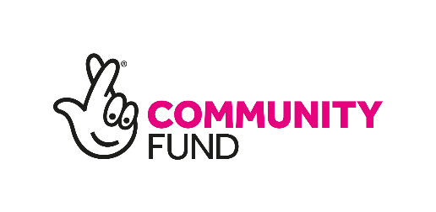
The National Lottery Community Fund (TNLCF) are keen to find out more about the funding needs of smaller community organisations to support you in your work with communities.
Our Regional Team and Awards for All Team are planning some local funding sessions, focusing on National Lottery Awards for All England. Awards for All is a quick way to apply for funding between £300 and £10,000.
We would really value some feedback to make sure that we can support you to access funding to support your Community. Your responses to our questions below will help us better understand your funding needs; plan local funding sessions to support you; and award more Awards for All grants to small community organisations in Darlington.
We are hosting a Coffee and Chat session on the 27th April between 1.30 and 4.30pm at Darlington Connect where you can pop along for a chat and a coffee, to find out more information, talk to us about your ideas and get some support with your application. We look forward to seeing you there!
Our funding
We're here to support communities with the things that are important to them, including mitigating the impact of the cost-of-living crisis and supporting them as they seek to recover, rebuild and grow following the Covid-19 pandemic.
We’ll also help communities celebrate the national events that are important to them - including the Coronation of His Majesty The King, The Eurovision Song Contest and the 75th anniversary of Windrush.
You can apply for funding to deliver a new or existing activity or to support your organisation to change and adapt to new and future challenges.
In order to support communities, we fund projects and organisations which aim to:
- build strong relationships in and across communities
- improve the places and spaces that matter to communities
- help more people to reach their potential, by supporting them at the earliest possible stage
- support people, communities and organisations that are facing increased demands and challenges as a direct result of the cost-of-living
Your funding needs
- Would your organisation and/or project benefit from an Awards for All grant?

- What grant size (£) would you need? (You can apply for any amount between £300 and £10,000)

- What would you need funding for?

- Have you previously applied to TNLCF for funding?

- What prevents you from applying to TNLCF for funding?

- Have you visited our website https://www.tnlcommunityfund.org.uk/funding/programmes/national-lottery-awards-for-all-england and does the information and support help you to complete an Awards for All online application?

- What support could we offer as a Fund to make the Awards for All application process simpler or more manageable?

- What would increase your likeliness of applying for Awards for All funding?

- What would you like to see or hear during our planned local funding sessions?

- Would additional support from a skilled local organisation make it easier to apply to TNLCF?

You will receive an invitation to a local event soon so that you can find out more about the grant application process and to answer any questions that you have. In the meantime, you can click or visit here to find out more about Awards for All funding opportunities How to get a grant for up to £10,000 | The National Lottery Community Fund (tnlcommunityfund.org.uk)

