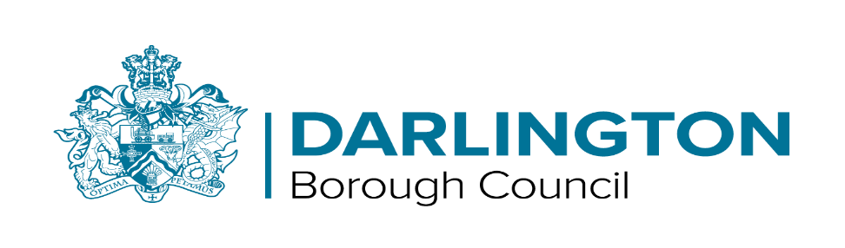

Disabled Facilities Grant and RRO Policy 2022 - 25

Following consultation and consideration by Cabinet, all proposed changes were agreed.

Disabled Facilities Grant and RRO Policy 2022-25 (darlington.gov.uk)

Those impacting directly on individual applications are as follows:

- Removal of the means test for the following adaptations (and any combination of these):

  - Stairlifts (Straight and Curved)
  - Ramps (semi-permanent)
  - Level Access Showers
  - Through Floor Lifts
  - Wash Dry Toilets

- Retaining the means test for ground floor extensions and garage conversions but increasing the land charge recovery threshold from £5,000 to £10,000.

- New Schemes added for:
  - provision of additional support such as safe spaces for children and adults with autism/behaviors that challenge
  - dementia grants to fund small modifications that would allow someone with a diagnosis of dementia to remain living safely in their home for longer.
  - smart home kits such as a smart thermostat to control heating and hot water
  - home accident prevention/health and safety such as minor adaptations and repairs, security checks, deep clean and de-cluttering of premises

To apply for support via the Disabled Facilities Grant contact:
Adult Social Care (for individuals aged 18+) - via telephone on 01325 406111 or via
the website
https://www.darlington.gov.uk/health-and-social-care/adult-services/contact-us/

Childrens Front Door – via telephone on 01325 406222 or via email
childrensfrontdoor@darlington.gov.uk

