Communications plan - Type 2 Diabetes prevention week 2023 (23 – 29 May)

Background
This communications toolkit has been created in collaboration with NHS North East and North Cumbria Integrated Care Board, Diabetes UK and NHS diabetes prevention programme. The toolkit aims to support increased awareness of Type 2 diabetes prevention, and encourages people to adopt healthy lifestyle behaviours to reduce their risk of developing Type 2 diabetes.

Objectives
- Increase awareness of Type 2 Diabetes
- Encourage people to take preventative measures and adopt healthier behaviours
- Promote the 'Know your risk tool'.
- Encourage people to contact their GP about the Healthier You: NHS Diabetes Prevention Programme

Activity and timings
22 – 28 May

Campaign content toolkit
- Suggested copy for bulletins and external channels – see below
- Social media content – see below

Join us on social media
Please do add the below social media handles to all your posts on social media platforms so that we can reshare them and ensure that the message reaches a wider audience.

- Facebook @ NorthEastandNorthCumbriaNHS
- Twitter: @NENC_NHS
- Twitter: @NHSDiabetesProg
- Twitter: @DiabetesUK

Campaign hashtags

#DiabetesIsSerious
#KnowYourRisk
#Type2Diabetes

Short copy (84 words)
Assessing your risk of type 2 diabetes is quick and easy with Diabetes UK's Know Your Risk tool. Millions of people in the UK are at high risk, but with the right care and support, it can be prevented or put into remission.
Take the first step towards a healthier future by completing the free online assessment today.
If you're at high risk or have a history of gestational diabetes, ask your GP about the Healthier You: NHS Diabetes Prevention Programme for tailored support.

Suggested Long copy – (192 words)
Finding out your risk of type 2 diabetes only takes a few minutes, but it could be the most important thing you do today....
Right now, millions of people across the UK are at high risk of developing type 2 diabetes. Diabetes is serious and every diagnosis is life changing. It’s a relentless condition, and the fear of serious complications is a lifelong reality for millions of people in the UK.
But it doesn’t have to be this way. With the right care and support many cases of type 2 diabetes can be prevented or put into remission.
Diabetes UK’s free, online Know Your Risk tool, supports people to understand their risk of developing type 2 diabetes. It takes just a few minutes to complete, advises you on your risk and some next steps that can help reduce this.
Anyone at high risk of type 2 diabetes, or with a history of gestational diabetes, can ask their GP to refer them for a free place on the local Healthier You: NHS Diabetes Prevention Programme. Those referred to the programme receive tailored, personalised support to reduce their risk of developing type 2 diabetes.

Social media assets

Copy for social media posts – edit to fit | Visual options – also see the toolkit
People from Black or South Asian backgrounds are at a higher risk of developing type 2 diabetes.  Diabetes UK’s free, online Know Your Risk tool, supports people to understand their risk of developing type 2 diabetes.  Find out your risk today 👇  Diabetes UK – Know Your Risk of Type 2 diabetes  #KnowYourRisk | 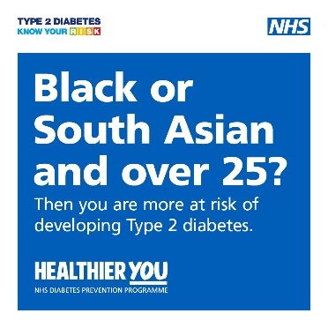
There are now over 1 million people diagnosed with diabetes across the North of England, with millions more people at high risk of developing type 2 diabetes.  Research shows that for some people; diet, physical activity, and sustained weight loss - can be effective in reducing the risk of type 2 diabetes by about 50%.  Find out more on preventing Type 2 diabetes here 👇  Understand your risk | Preventing type 2 diabetes | Diabetes UK | 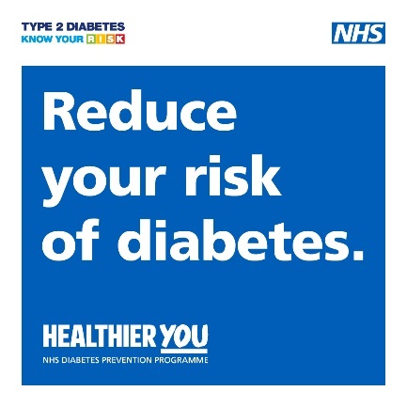
Its Type 2 Diabetes Prevention Week! We're raising awareness of the risk of Type 2 diabetes and sharing the care and support that’s available to help reduce your risk.  If you're at high risk or have a history of gestational diabetes, ask your GP about the Healthier You: NHS Diabetes Prevention Programme for tailored support.  Find out more at Understand your risk | Preventing type 2 diabetes | Diabetes UK  #DiabetesIsSerious #Type2Diabetes | 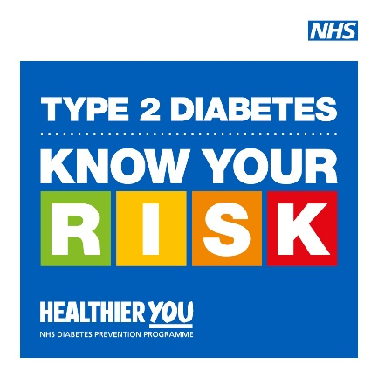
Are you at risk of type 2 diabetes? Right now, millions of people across the UK are at high risk of developing type 2 diabetes. Diabetes is serious and every diagnosis is life changing.  Find out your risk today 👇  Diabetes UK – Know Your Risk of Type 2 diabetes | 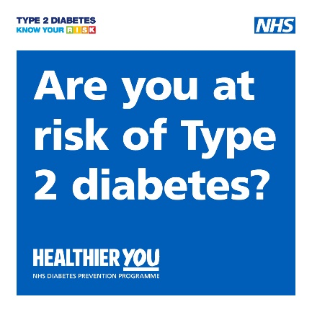

For more information contact: Anisah.sharmeen@nhs.net

